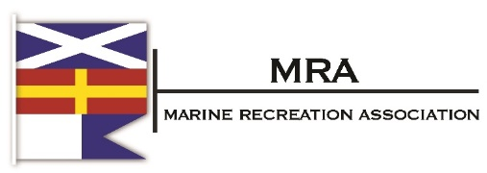
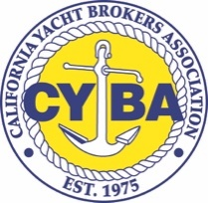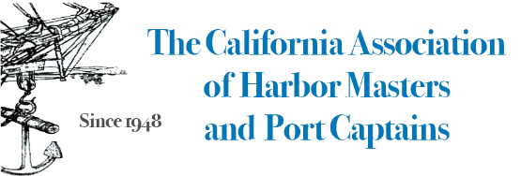

May 10, 2022
The Honorable Phil Ting
State Assembly
1021 O Street
Sacramento, CA 95814

RE: AB 1817 (As Amended May 9, 2022)– OPPOSE UNLESS AMENDED

Dear Assembly Member Ting:

On behalf of the undersigned associations representing recreational boating in California, we must respectfully continue to OPPOSE UNLESS AMEND AB 1817, which would ban for sale in the state any textile article containing perfluoroalkyl and polyfluoroalkyl (PFAS) substances, with little exemptions, by 2025.

Our industry relies on the advanced U.S. textile sector to utilize advanced and durable fabrics and parts, equipped to last in the harsh outdoor, salt water environment. Durable fabrics not only protect against grease and stains inherent to being outside on the water, but they also protect boats and their participants, there would be degradation of many of the ship’s parts.

In the Assembly Environmentally Safety and Toxic Materials Committee on March 22, 2022 it was made clear that this bill was not intended to include boating materials nor the automotive industry. We would respectfully request a similar amendment that excludes the automotive industry in Section 108970(g)(2) for watercraft uses.

Fabric manufactures are working in earnest to develop textile alternatives to fluorotechnology, but there is not a sufficient alternative yet that provides the strength, durability, waterproof and greaseproof that our industry needs in their textiles. These fabrics are not bioavailable and don’t run into the water. This bill would negatively impact an important industry in this state, particularly the robust resale market for boats.

For these reasons, we request AB 1817 be amended to exclude the marine industry.
Sincerely,

Kate Pearson
President, MRA

Peter Zaleski
President, CYBA

Andrea Lueker
President, CAHMPC

