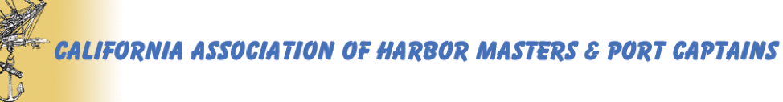
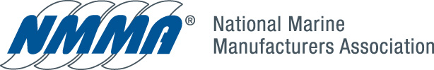
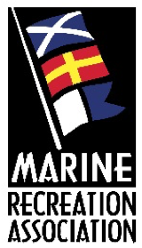

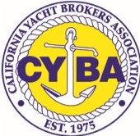
July 1, 2019

Honorable Laura Friedman
Assemblywoman, AD 43
State Capitol, Room 2137
Sacramento, CA 95814

Dear Assemblywoman Friedman,

RE: AB 1111 – Support with an amendment

We, the collection of undersigned recreational boating interests, ask that you accept a friendly amendment to your AB 1111 to ensure the voices of California’s boaters and users of waterways (both motorized and non-motorized) are appropriately represented on the Office of Outdoor Recreation advisory committee.

We ask that in addition to a representative from California Department of Parks and Recreation that you specifically require the participation of a representative from the Division of Boating and Waterways (DBW).

DBW was only recently consolidated with the Department under the Natural Resources Agency, and still requires a Senate confirmation for its Deputy Director and functions uniquely within Parks with its role and responsibility to boating and waterway programs. This distinction is appropriate given that DBW’s focus, and the size of the recreational boating industry, require unique and dedicated services.

In California, recreational boating has an estimated direct and indirect annual economic impact of $13 billion. It provides 41,100 jobs and directly supports 2,820 businesses. There are 745,640 boats registered in California (second only to Florida), and Californians spent $718 million in 2018 on new boats, engines, trailers and accessories.

California is third in the country in our amount of coastline. Ocean fishing and inland river fishing (most of which requires boats) is a much sought-after recreational activity and draws thousands of tourists to California waterways every year. California’s tens of thousands of miles of waterways provide unlimited recreational opportunities for motorized and non-motorized enthusiasts, provide they are maintained, clear of vegetation, and have reliable public access.

DBW also oversees many of the state’s programs discussed on the findings of your bill, include beach erosion and climate impacts on California’s public and private port, harbor, marina and waterway infrastructure.

Thank you in advance for listening to our concerns and working with us to address them. We look forward to working with you on this amendment, which we believe strengthens the Office of Outdoor Recreation and ensures the boating community is participating at the table.

Sincerely,

California Association of Harbor Masters and Port Captains
California Yacht Brokers Association
Marine Recreation Association
National Marine Manufacturers Association

