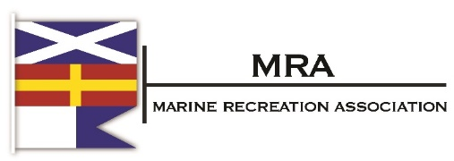
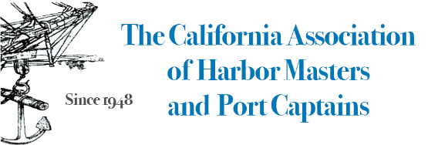

June 30, 2022
The Honorable Phil Ting
State Assembly
1021 O Street
Sacramento, CA 95814

RE: AB 1817 – Neutral Position

Dear Assembly Member Ting:

This is to confirm that the undersigned associations representing recreational boating in California has removed its opposition to AB 1817 as amended today and has a “neutral” position on the measure. Thank you for the consideration of our concerns with the measure.
Sincerely,

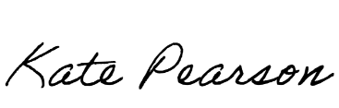
Kate Pearson
President, MRA

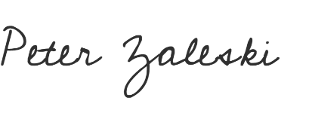
Peter Zaleski
President, CYBA
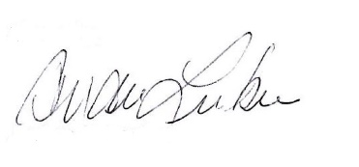
Andrea Lueker
President, CAHMPC

